  - Types of optical lenses
Different curves of lenses
For farsightedness, lenses are thicker in the center and thinner on the edges (convex lenses). A farsighted prescription is written with a “plus” sign, e.g. +2.00 diopters (D).
For nearsightedness, lenses are thinner in the center and thicker on the edges (concave lenses). A nearsighted prescription is written with a “minus” sign, e.g.-2.00 diopters (D).
Cylindrical lenses are ideal for individuals suffering from a deformation of the cornea – better known as astigmatism. A cylindrically shaped lens will help compensate for this condition.

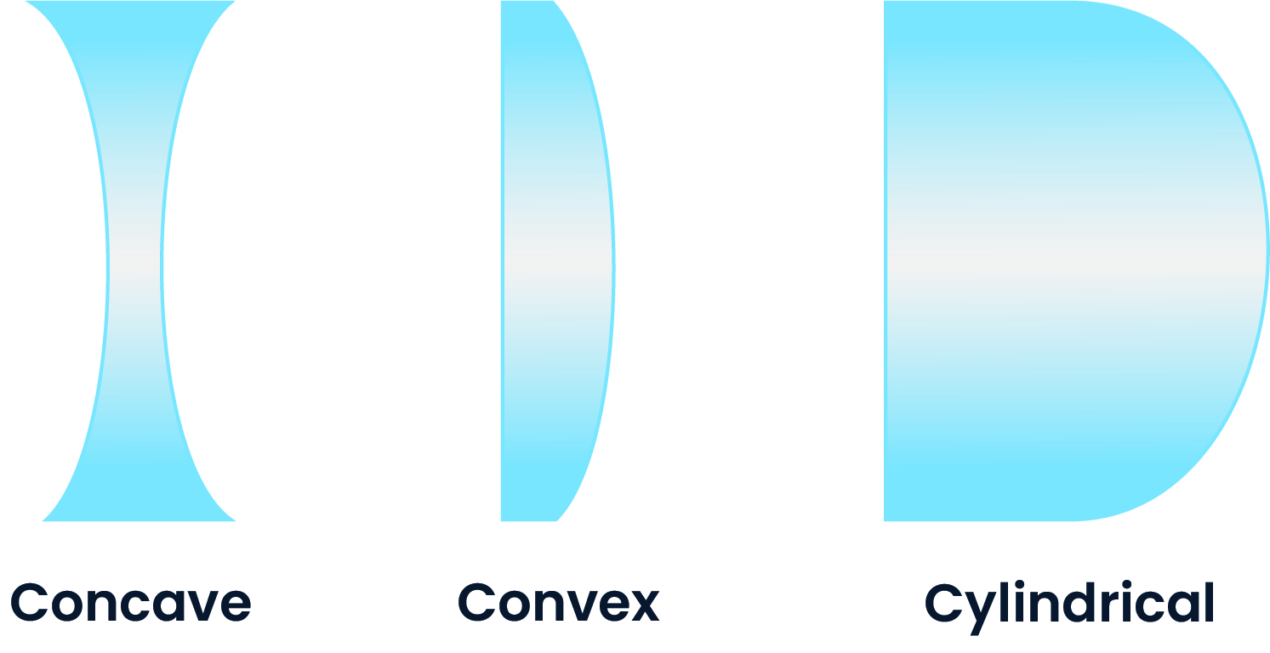
Different types of lenses
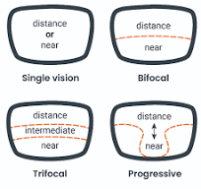

Single vision lenses are the most basic, and least expensive type of lenses. These lenses fix one vision problem. People use them for myopia, hyperopia, or astigmatism. Monofocal lenses focus light on one spot. This gives clear sight for near or far things.

Multifocal lenses help people see at more than one distance. These lenses include bifocal, trifocal, and progressive lenses. Multifocal lenses have zones for near, middle, and far vision. Multifocal lenses mean you do not need many pairs of glasses. Multifocal lenses help with comfort and safety for driving or sports. These lenses are good for people who want clear sight at all distances.
- Bifocal lenses contain two optical powers to accommodate clear vision for both near and far. The lens is divided into two segments, the top of the lens contains the distance vision prescription, while the bottom of the lens contains the near vision prescription. Some bifocals contain a bisecting horizontal line between the two lens powers. People with presbyopia use bifocals to read and see far.

- Trifocal lenses contain three optical powers - distance, intermediate and near vision, with two segmenting lines to outline the powers. The intermediate segment is located above the segment for near vision and is helpful for viewing objects at arm’s length, such as a computer.

- Progressive lenses, also called multifocal lenses are similar to bifocals and trifocals, but contain multiple lens powers to provide vision at all distances - close up, intermediate, distance, and any other lens power necessary for vision clarity. Multifocals gradually blend the lens powers together without a bisecting line, making them more attractive than bifocals. The downside of multifocals is that the clear zone for each part of the lens may be limited. Progressive lenses feel natural, but some people need time to get used to them.

Specialty lenses: photochromic, polarized, blue light blocking, prism, aspheric
Specialty lenses help with special vision needs. These lenses include photochromic, polarized, blue light blocking, prism, and aspheric lenses.
Photochromic lenses also known as transition lenses, are clear indoors and darken when exposed to sunlight. These lenses eliminate the need for sunglasses and are more convenient for those who wear glasses full time to protect their eyes from UV radiation. Photochromic lenses lower the risk of cataracts.
Polarized lenses reduce glare from surfaces such as water and snow. They are an ideal choice for driving and playing sports. Polarized lenses block UV rays and help people see well in bright places.
Blue Light Blocking (Computer) lenses filter out blue light - reducing eye strain, and headaches- and protecting overall ocular health. Computer glasses may be purchased without a prescription. If you already wear prescription glasses, your lenses can be treated with a blue light-blocking coating.
Prism lenses fix double vision and other sight problems. These lenses move light to the right spot on the retina.
Aspheric lenses use special designs to stop distortion. Their curve is flatter so they are thinner and lighter.
https://www.optometrists.org/general-practice-optometry/optical/guide-to-optical-lenses/optical-lenses/
https://www.band-optics.com/blog/types-of-optical-lenses-and-their-uses.html
https://www.keeler.co.uk/blog/post/different-types-ophthalmic-lenses
VOCABULARY
coating - covering of something
distortion - a change in the shape or appearance
glare - strong and dazzling light
presbyopia - a physiological insufficiency of optical accommodation associated with the aging of the eye; it results in progressively worsening ability to focus clearly on close objects
I. Match the words in English to their Polish translations.
ENGLISH | POLISH
1. eyeglass lenses | a. soczewki jednoogniskowe
2. transition lenses | b. soczewki trójogniskowe
3. single vision lenses | c. soczewki wieloogniskowe
4. bifocal lenses | d. soczewki przejściowe
5. multifocal lenses | e. soczewki okularowe
6. trifocal lenses | f. soczewki pryzmatyczne
7. prism lenses | g. soczewki dwuogniskowe

II. Complete the table
Lens Type | Applications | Advantages
Single vision
Bifocal
Trifocal
Progressive
Photochromic
Polarised
Blue light blocking
Prism
Aspheric


Ćwiczenia na licencji Creative Commons
mgr Marzena Gorczyca-Blok

